ABOUT THIS SECTION

The information in this section was summarized from this report, which includes more detailed information and all references cited:

* [***Review of Odour Prevention and Mitigation Tools for Alberta***](http://casahome.org/Portals/0/documents/Odour%20Management/Consultant%20Reports/PMTG%20Pinchin%20Final%20Report%20w%20Appendices%202015-01-27.pdf?timestamp=1436886856110) which was prepared for the Clean Air Strategic Alliance by Pinchin Ltd.

The full report also includes case studies for:

* A Municipal Waste Management Facility
* A Secondary Food Processing Facility
* The Development of Odour Guidance from a Multi-stakeholder Group

Odour Prevention and Mitigation

Prevention and mitigation can be described as a suite of tools used to prevent or lower odorant emissions or reduce the occurrence of adverse odour effects.

* Prevention refers to actions or solutions that avert the creation of odours, such as material substitution.
* Mitigation techniques are more commonly used and target odours after they are generated

There are various prevention and mitigation tools that can be used depending on the circumstance and their selection is often guided by odour assessment tools.

* [**Source-Pathway-Receptor Model**](http://casahome.org/CurrentInitiatives/GoodPracticesGuideforOdourManagementinAlberta/OdourPreventionandMitigation.aspx#spr)
* [**Plan, Do, Check and Act Model**](http://casahome.org/CurrentInitiatives/GoodPracticesGuideforOdourManagementinAlberta/OdourPreventionandMitigation.aspx#plan)
* [**Prevention and Mitigation Tools Description**](http://casahome.org/CurrentInitiatives/GoodPracticesGuideforOdourManagementinAlberta/OdourPreventionandMitigation.aspx#prevention)
* [**Charts/Tools and Reference Materials**](http://casahome.org/CurrentInitiatives/GoodPracticesGuideforOdourManagementinAlberta/OdourPreventionandMitigation.aspx#charts)

SOURCE-PATHWAY-RECEPTOR MODEL

To effectively study and manage odours, an understanding of how odours are created, transported and affect humans is required. One common model used to study odours is the Source-Pathway-Receptor (SPR) conceptual model, which generally traces how substances move from an origin to a final destination. This model can apply to various materials and different media and it has been used in environmental studies such as impact, health and environmental assessments.

**[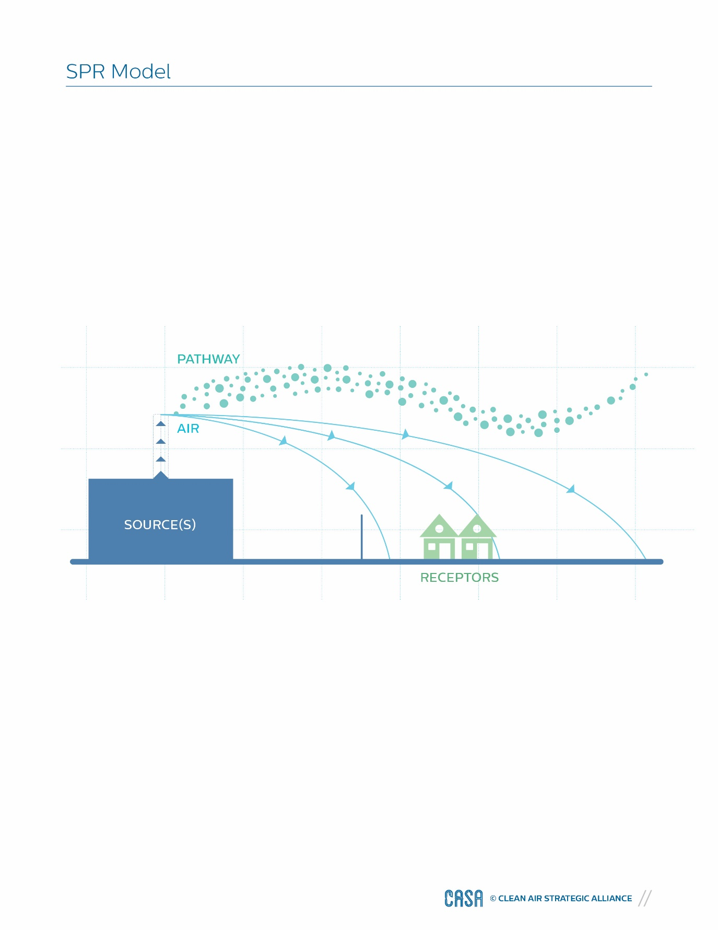](http://casahome.org/Portals/0/DMX/OMT%20GPG/SPR.pdf?timestamp=1444750645335)**

The nature of the source determines and defines how and where the odour is released into the environment. The odorants will travel through an air pathway, carried by wind that may pass by a fence, trees and/or other objects. Finally, individuals at places where people dwell, work, learn and meet become the receptor, and they may or may not be adversely affected by the odorants. All three components of the model must be linked for a potential odour exposure or adverse effect to occur (DEFRA, 2007).

Prevention techniques block the linkages in the model, while mitigation options reduce the severity of the adverse effect.

[**Back to Top of Page**](http://casahome.org/CurrentInitiatives/GoodPracticesGuideforOdourManagementinAlberta/OdourPreventionandMitigation.aspx)

PLAN, DO, CHECK AND ACT MODEL

The Plan, Do, Check and Act (PDCA) model is a basic management principle, which allows for the good management and improvement of products and systems. It provides a framework for improvement and its cyclic nature can be self-regulating (IAQM, 2014).

The PDCA model can be adopted for environmental management systems related to air quality, specifically odour prevention and mitigation. Planning documents, such as prevention and mitigation plans (PMP), should be “living” documents that are constantly evaluated and adjusted as needed (Bull et al., 2014; DEFRA, 2006).

Generally, the four phases are:

* **Plan** – includes initial discovery, screening and assessment of the odour potential of the site or facility, and then establishing appropriate goals and objectives. Review of possible options, scenarios and their probability to reduce adverse effects will lead to the adoption of a plan to move forward.
* **Do** – involves implementing the adopted plan and installing or establishing the prevention and mitigation tools and monitoring requirements.
* **Check** – ensures systems are commissioned according to requirements during implementation. Establish and use the monitoring systems and internal checks to evaluate the systems.
* **Act** – involves maintaining and re-evaluating the odour potential, plans and systems. Act and improve as needed.

 See [**Figure 1**](http://casahome.org/Portals/0/DMX/OMT%20GPG/CASA_GPG_webversion_Figure01.pdf?timestamp=1444750801521) to view how the PDCA model fits with the tools described in this section.

**[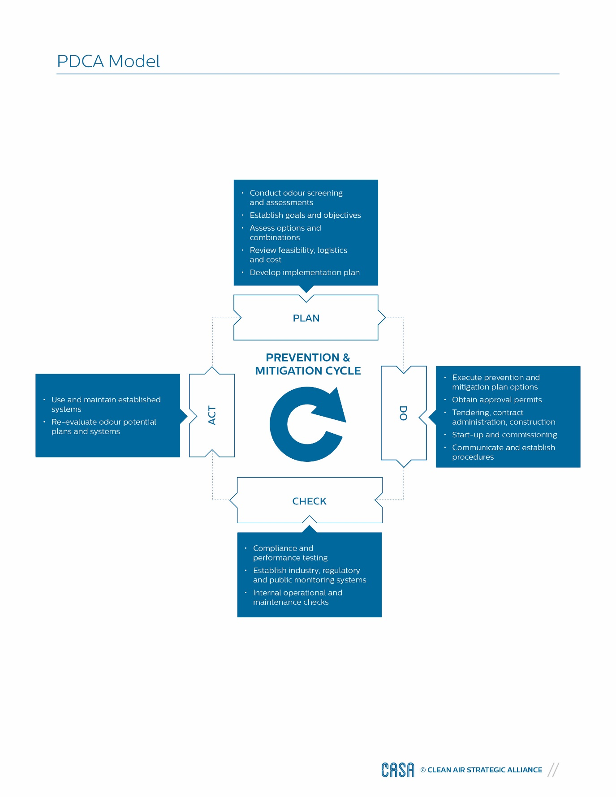](http://casahome.org/Portals/0/DMX/OMT%20GPG/PDCA.pdf?timestamp=1444750677779)**

[**Back to Top of Page**](http://casahome.org/CurrentInitiatives/GoodPracticesGuideforOdourManagementinAlberta/OdourPreventionandMitigation.aspx)

PREVENTION AND MITIGATION TOOLS

Tools for odour prevention and mitigation must be established based on a goal and associated objectives. The suite of prevention and mitigation tools listed in this guide have been divided into general categories and summarized below. More detailed descriptions of the tools are available in the full report [***Review of Odour Prevention and Mitigation Tools for Alberta***](http://casahome.org/Portals/0/documents/Odour%20Management/Consultant%20Reports/PMTG%20Pinchin%20Final%20Report%20w%20Appendices%202015-01-27.pdf?timestamp=1436886856110).

Tools can target specific parts of the Source-Pathway-Receptor model or be implemented at several locations. Many of the tools target the source of odours and can work better for different types of sources (point, line, area, volume and multi sources).

* [**Land Use and Planning Development**](http://casahome.org/CurrentInitiatives/GoodPracticesGuideforOdourManagementinAlberta/OdourPreventionandMitigation.aspx#landuse)
* [**Site Management**](http://casahome.org/CurrentInitiatives/GoodPracticesGuideforOdourManagementinAlberta/OdourPreventionandMitigation.aspx#site)
* [**Raw Materials, Formulation, Process and Operational Modifications**](http://casahome.org/CurrentInitiatives/GoodPracticesGuideforOdourManagementinAlberta/OdourPreventionandMitigation.aspx#raw)
* [**Management Planning Groups and Guides**](http://casahome.org/CurrentInitiatives/GoodPracticesGuideforOdourManagementinAlberta/OdourPreventionandMitigation.aspx#management)
* [**Establishing Community and Neighbourhood Relations**](http://casahome.org/CurrentInitiatives/GoodPracticesGuideforOdourManagementinAlberta/OdourPreventionandMitigation.aspx#community)
* [**Real-time Downwind Monitoring**](http://casahome.org/CurrentInitiatives/GoodPracticesGuideforOdourManagementinAlberta/OdourPreventionandMitigation.aspx#realtime)
* [**Atmospheric Dispersion Optimization and Pathway Buffering**](http://casahome.org/CurrentInitiatives/GoodPracticesGuideforOdourManagementinAlberta/OdourPreventionandMitigation.aspx#atmospheric)
* [**Engineering Controls**](http://casahome.org/CurrentInitiatives/GoodPracticesGuideforOdourManagementinAlberta/OdourPreventionandMitigation.aspx#engineering)
* [**Masking and Neutralizing Agents**](http://casahome.org/CurrentInitiatives/GoodPracticesGuideforOdourManagementinAlberta/OdourPreventionandMitigation.aspx#masking)
* [**Receptor-based Tools**](http://casahome.org/CurrentInitiatives/GoodPracticesGuideforOdourManagementinAlberta/OdourPreventionandMitigation.aspx#receptor)

[**Back to Top of Page**](http://casahome.org/CurrentInitiatives/GoodPracticesGuideforOdourManagementinAlberta/OdourPreventionandMitigation.aspx)

Land Use and Planning Development

Land use and planning development is a pathway tool, which generally works by setting a minimum pathway distance or buffer zone between potential odour sources and sensitive receptors. This tool is mainly preventative and applies to all types of sources. Effective application of land use and development planning tools require the participation and active engagement of multiple stakeholders who often have conflicting goals. Establishing planning protocols and conditions to the individual nature of the odour at a site or facility is complex and requires skill (DEFRA, 2010).

|  |  |
| --- | --- |
| BENEFITS | CONSIDERATIONS |
| * As a prevention tool, can drastically reduce or eliminate potential for adverse odour effects * Limits the risk of conflicting land uses or changes in land use | * Multi-stakeholder process with conflicting goals * Buffer zones and set back distances may not be suitable for densely developed areas * Due to the nature of odour, cases may still require other tools |

[**Back to Prevention and Mitigation Tools**](http://casahome.org/CurrentInitiatives/GoodPracticesGuideforOdourManagementinAlberta/OdourPreventionandMitigation.aspx#prevention)

Site Management

Site management is a key consideration that can prevent and mitigate odour sources from planned or existing facilities (Anderson et al., 2003). Some of the major considerations for overall site management include:

**Existing, modified or proposed sites**

Existing, modified or proposed sites can all benefit from prevention and mitigation planning; however, each requires slightly different approaches. Existing and modified sites may have a more limited selection of feasible prevention options compared to proposed sites as land use designations have already been assigned and the sites may be located in densely populated areas. Proposed sites generally have more and easier opportunities to apply prevention techniques; however, in such cases the exact composition and offensiveness of potential odour sources may be unknown, as there is no historical data.

**The nature of odorant**

Combinations of odour intensity, duration, frequency and character all have an influence on the potential to create an adverse effect (see[**FIDOL factors**](http://casahome.org/CurrentInitiatives/GoodPracticesGuideforOdourManagementinAlberta/UnderstandingOdour.aspx#characterizing)). With knowledge of the odour nature and receptor response, appropriate prevention and mitigation goals can be set and suitable combinations of prevention and mitigation options can be reviewed.

**Regulatory regime**

Odours causing an adverse effect are prohibited under legislation. Defining when odour effects occur is not an easy task. It is important to characterize the problem (perhaps using [**FIDOL factors**](http://casahome.org/CurrentInitiatives/GoodPracticesGuideforOdourManagementinAlberta/UnderstandingOdour.aspx#characterizing)) to identify a potential impact, and then set measurable goals and objectives in prevention and mitigation planning. Facilities should approach the problem knowing that the threshold for adverse effects may be an unknown or a moving target and that planning and implementation can take several iterations.

[**Back to Prevention and Mitigation Tools**](http://casahome.org/CurrentInitiatives/GoodPracticesGuideforOdourManagementinAlberta/OdourPreventionandMitigation.aspx#prevention)

Raw Materials, Formulation, Process and Operational Modifications

Raw materials, formulation, process and operational modifications are prevention techniques with the objective of stopping or reducing the creation of odorants. They can apply equally to all types of processes and source types. Simple operational modifications, such as improved housekeeping and minimizing leaks, can result in good management improvements for area, volume and line sources. Knowledge and review of the facility process flows and operations is required to identify possible opportunities while minimizing impacts to facility production.

|  |  |
| --- | --- |
| BENEFITS | CONSIDERATIONS |
| * Prevention techniques can drastically reduce or eliminate the potential for odour * Operational/maintenance modifications can be simple and easy to implement | * Material substitutions can require expensive and time consuming trials * Process changes may affect the quality of products |

[**Back to Prevention and Mitigation Tools**](http://casahome.org/CurrentInitiatives/GoodPracticesGuideforOdourManagementinAlberta/OdourPreventionandMitigation.aspx#prevention)

Management Planning Groups and Guides

Management planning groups and guides are a prevention tool that can be used at any type of source. This tool refers to the organization and benefits of common interest groups and development of best management practices. Management planning groups can take various forms, such as regulatory committees, industry groups, non-governmental organizations and community-based groups. At the same time, it is common to have these management groups and bodies publish guides and documentation on process, air emissions, permitting requirements, innovation in technology and regulation changes.

|  |  |
| --- | --- |
| BENEFITS | CONSIDERATIONS |
| * Collects and provides practical knowledge from various sources * Guides are targeted at specific industries, processes or operations and provide relevant information * Implementation of tools developed by management planning groups are typically proven to be effective and more universally accepted by regulators and the general public | * Does not directly prevent or mitigate odour emissions unless effectively implemented * Material may take time to be published and can become dated over time * Can be general in nature leaving interpretation and detailed planning at the discretion of the user |

[**Back to Prevention and Mitigation Tools**](http://casahome.org/CurrentInitiatives/GoodPracticesGuideforOdourManagementinAlberta/OdourPreventionandMitigation.aspx#prevention)

Establishing Community and Neighbourhood Relations

Establishing good community and neighbourhood relations is a prevention and mitigation tool that can be used at the receptor to adjust the sensitivity and tolerance of the community to odour. Attempts to solve odour nuisance issues often over-emphasize technical solutions. One underestimated aspect of odour management is public opinion within the local community regarding the facility. A negative outlook from the surrounding neighbours may diminish any benefits obtained from using prevention and mitigation tools. Engaging the community in two-way dialogue fosters cooperation and trust. An actively engaged and informed community may lead to more realistic expectations about odours (Longhurst et al., 2004). The community itself can also become a valuable source of qualitative data, providing information to be used when assessing other prevention and mitigation tools (Anderson et al., 2003).

|  |  |
| --- | --- |
| BENEFITS | CONSIDERATIONS |
| * Creates a partnership, rather than an adversarial environment * Applicable for proposed and existing facilities * Can provide additional qualitative data for other tools | * Each community is different, requiring a custom approach and relations plan * Difficult to evaluate effectiveness * Does not directly reduce odour emission or transmission |

[**Back to Prevention and Mitigation Tools**](http://casahome.org/CurrentInitiatives/GoodPracticesGuideforOdourManagementinAlberta/OdourPreventionandMitigation.aspx#prevention)

Real-time Downwind Monitoring

Real-time downwind monitoring is a prevention and mitigation tool if the monitored parameters are representative of the odour and frequently monitored (real-time), and if appropriate action levels are established. “Real-time” refers to continuous and near instant reporting of monitoring results. With near instantaneous knowledge of odorants, alerts can be provided and corrective actions can be quickly taken to reduce the potential for the odour effect to become more significant. Corrective actions can be built into operating procedures and further automated to interact with the facility processes.

|  |  |
| --- | --- |
| BENEFITS | CONSIDERATIONS |
| * Provides early warning alerts and allows economic use of other prevention and mitigation tools * Can be implemented as part of an odour assessment or monitoring program * Can provide additional qualitative data for other prevention and mitigation tools | * Requires site specific calibration and odour assessment * May require specialized knowledge to operate and maintain * Does not directly prevent or reduce the odorants and can be costly to implement and maintain |

Atmospheric Dispersion Optimization and Pathway Buffering

Atmospheric dispersion optimization and pathway buffering will affect odour as it travels through the pathway between the source and the receptor. Optimizing discharge parameters is a mitigation technique used at the source that will affect the pathway through which the odour will disperse and dilute. Improved dispersion measures are most often implemented to reduce impacts of wind-induced turbulence caused by buildings and structures in the vicinity of the odorous discharge. Shelterbelts and artificial windbreaks are environmental barriers or pathway buffers that modify the pathway and change the amount of dispersion and dilution as the air moves. Trees and shrubs of varying heights, contained within multiple rows, provide dispersion and dilution, erosion and snow protection, and wildlife habitat, while reducing wind-related energy losses and enhancing landscapes.

**Atmospheric Dispersion and Source Optimization**

|  |  |
| --- | --- |
| BENEFITS | CONSIDERATIONS |
| * Straightforward, low maintenance and effective tool for point sources * Typically more economical than other engineering control tools * Applicable for proposed and existing facilities | * Typically not economical or feasible for area, volume and line sources * Potential negative visual perception and reaction from surrounding land users |

**Shelterbelts and Artificial Windbreaks**

|  |  |
| --- | --- |
| BENEFITS | CONSIDERATIONS |
| * Simple and natural solution * Additional benefits include energy conservation, wildlife habitat, reduced erosion and landscape enhancement * Can be implemented with permanent or temporary (portable) installations | * Can require large area to properly implement (length and width) * Shelterbelts can take a long time to fully develop and become effective * Only practical for low level sources |

Engineering Controls

Engineering controls are put in place at the source of the Source-Pathway-Receptor model to mitigate odour emissions before they are released to the atmosphere and travel towards receptors. Since there are many odorous substances, a variety of different types of engineering controls are available which use physical, chemical and biological principles to mitigate odours. Engineering source controls are sometimes referred to as “end of pipe” or “back end” solutions, which signify their deployment at the end of process units. Engineering controls are divided into five broad categories and include (but are not limited to):

**Table 1: Comparison of Engineering Controls (adapted from DEFRA, 2010)**

✓✓✓     Common, typically used and established

✓✓       Use may be limited to specific process and scale

✓     Rare usage and limited research

|  |  |  |  |  |  |
| --- | --- | --- | --- | --- | --- |
| ODOUR-EMITTING PROCESS | ABSORPTION | ADSORPTION | BIOLOGICAL | THERMAL OXIDATION | CONDENSATION |
| **Sewage treatment** | ✓✓ | ✓✓ | ✓✓✓ | ✓ | - |
| **Food processing and kitchens** | ✓✓✓ | ✓ | ✓✓✓ | ✓ | ✓ |
| **Paints and solvents** | ✓✓ | ✓✓ | ✓ | ✓✓✓ | ✓✓ |
| **Animals and livestock** | ✓✓ | ✓ | ✓✓✓ | - | - |
| **Industrial/chemical processes** | ✓✓ | ✓✓ | ✓ | ✓✓✓ | ✓✓ |
| **Oil and gas** | ✓✓ | ✓✓ | ✓ | ✓✓✓ | ✓✓✓ |
| **Storage and spills** | ✓✓✓ | ✓✓✓ | ✓ | ✓ | - |

**Absorption systems**

Absorption scrubbers, sometimes referred to as wet scrubbers, use a scrubbing liquid that is sprayed or showered within the odour-bearing gases. The odorous compounds then dissolve or react with the liquid and are removed from the liquid agent (Anderson et al., 2003). Types of absorption equipment and wet scrubbers include plate absorbers, venture absorbers, packed towers, tray towers and spray towers (DEFRA, 2010; Davis, 2000).

|  |  |
| --- | --- |
| BENEFITS | CONSIDERATIONS |
| * Proven and effective for soluble odorous contaminants and for use within certain sectors * Can handle a wide concentration range of odorous contaminants * Are suitable for humid applications * Can handle gas streams with particulate matter | * Creates a liquid waste stream, which must be treated and disposed of * Requires ongoing maintenance and expertise to properly operate * Some liquid solutions themselves have undesirable odours * Not suited for high temperature sources |

**Adsorption systems**

Contaminants get attached to the adsorption component through the pores of the material and are removed. Some common adsorption scrubbers use activated carbon or aluminum pellets because of their highly porous surfaces (DEFRA, 2010). Some adsorbents can be desorbed and reused (Anderson et al., 2003).

|  |  |
| --- | --- |
| **BENEFITS** | **CONSIDERATIONS** |
| * Proven and effective over a wide range of contaminants * Particularly suited for low temperature, low contaminant concentration or mass loading gas streams * Media can be specifically chosen for the odorants and multimedia systems are available * Equipment and components are simpler and the systems are easier to operate * Can be used as a concentrator ahead of thermal oxidation or condensation solvent recovery | * Media becomes loaded and has to be replaced or regenerated periodically * Not suitable for odour streams containing excess water, grease, oil or particulate matter since surfaces of the media can become clogged * May not be suitable for high contaminant concentration applications due to high replacement or regeneration requirements, unless used as a concentrator ahead of other control technologies * Not suitable for high temperature application * Regeneration stream requires further treatment |

**Biological**

Treatment systems with biological components use micro-organisms to break down odorous compounds and reduce odour releases. Biological components can be sprayed into the odorous air stream; however, the most common systems pass the air stream through a porous support media where the micro-organisms establish a population. This self-sustaining system allows for many different biological species and support media as long as the media does not degrade. Support materials include soil, wood chips, inorganic porous minerals and calcified seaweed (DEFRA, 2010).

|  |  |
| --- | --- |
| BENEFITS | CONSIDERATIONS |
| * Self-sustaining system over an extended period of time * Applicable to water soluble bio-degradable contaminants * Has the potential for high removal efficiencies * Relatively low operating costs | * May not respond quickly to frequent or wide fluctuations in contaminant concentrations * Not effective with high contaminant concentration streams * Requires higher residence time, large areas and competent workers to maintain * Requires watering to maintain moist environment for bacterial growth. * Not tolerant to high temperatures, pesticides and other poisons |

**Thermal**

Thermal systems consist of several different methods aimed at oxidizing odorous compounds with the addition of heat and combustion. Thermal oxidation converts odorous compounds into water and carbon dioxide (Anderson et al., 2003). Thermal systems can include thermal oxidizers, catalytic thermal oxidizers, recuperative thermal oxidizers and regenerative thermal oxidizers (Rafson, 1998; Davis, 2000).

|  |  |
| --- | --- |
| BENEFITS | CONSIDERATIONS |
| * Highly effective at converting odorous compounds * Odorous compounds are converted within short residence times * Waste heat can be recovered for pre-heating incoming odorous gas and other uses in the facility * Particularly applicable to higher concentration hydrocarbon-based streams * Applicable to a wide range of contaminants | * High capital costs if energy recovery technology is included * Energy costs are high for low contaminant concentration streams, especially if energy recovery is not employed * Catalytic systems can exhibit varying conversion efficiencies on some contaminants and certain contaminants can be a catalyst inhibitor or poison * Catalyst requires regeneration or replacement over time * Improperly executed thermal system can create more toxic chemicals and/or odorants |

**Condensation**

Condensation is a somewhat special technique applicable to innately hot gases, where odorants are removed and transferred into a liquid stream by lowering temperatures. It is typically used as part of hydrocarbon systems within petroleum applications, but applicable to other hot, high volatile organic compound sources.

|  |  |
| --- | --- |
| BENEFITS | CONSIDERATIONS |
| * Potential to reuse recovered product * Mostly applicable to high VOC concentrations in gas steams at lower temperatures * Can be coupled with adsorption technologies * Typically low to moderate capital cost | * Relatively small range of use and application * Typically requires special electrical and additional safety considerations due to concentrated VOC levels * Requires qualified operating personnel and operating costs can be substantial * If recovered solvent is not reused, then hazardous waste disposal will be required |

[**Back to Prevention and Mitigation Tools**](http://casahome.org/CurrentInitiatives/GoodPracticesGuideforOdourManagementinAlberta/OdourPreventionandMitigation.aspx#prevention)

Masking and Neutralizing Agents

Masking and neutralizing agents are sprayed, mixed and applied to odorous liquids, surfaces or gases to mitigate adverse odour effects. These agents act in the form of a mitigation tool or can be used for the prevention of odour releases at the source. Agents that are applied directly to the odorous substance or source can mask, inhibit and prevent odour releases from being created or leaving the source. Surface treatments are mainly used in livestock facilities, bio-waste facilities and composting sites where the sources have large surface areas and agents can be applied with ease (Jacobs et al., 2007). When applied to odorous gases, agents act as mitigation tools to reduce the odour impact.

|  |  |
| --- | --- |
| BENEFITS | CONSIDERATIONS |
| * Reduces offensive odours and releases a more pleasant smelling odour * Depending on the substance used, this tool is easy to implement * Typically applicable to area and volume sources and some selective point sources | * Efficiency of masking and neutralizing agents can vary with meteorological conditions * After prolonged exposures to treatment agents, the smells of the deodorizers and agents may become offensive to some people. * Combining masking agents with certain chemicals can result in more offensive odours * Typically does not work well on sources with low contact residence time, such as point sources |

[**Back to Prevention and Mitigation Tools**](http://casahome.org/CurrentInitiatives/GoodPracticesGuideforOdourManagementinAlberta/OdourPreventionandMitigation.aspx#prevention)

Receptor-based Tools

Receptor-based tools are typically used for multi-sources and require the cooperation of various parties to properly implement. Receptor tools can be used reactively as the “last chance” to resolve odour issues or proactively by progressive planning groups. Some receptor tools include restricting the receptor land uses, warning signage, agreement clauses and receptor mitigation. There is limited research and case studies on the use of these tools and even less information about their effectiveness.

[**Back to Top of Page**](http://casahome.org/CurrentInitiatives/GoodPracticesGuideforOdourManagementinAlberta/OdourPreventionandMitigation.aspx)

ODOUR PREVENTION AND MITIGATION CHARTS AND TOOLS

The following charts provide guidance on the factors to consider when determining the potential for odours and the planning and measures that should be considered to prevent or mitigate odours.

* [**Table 2 – Guideline for Planners, Regulators and Facility Operators**](http://casahome.org/Portals/0/DMX/OMT%20GPG/CASA_GPG_webversion_Table02.pdf?timestamp=1444749578035)
* [**Figure 1 – Prevention and Mitigation Planning and Implementation Flow Chart**](http://casahome.org/Portals/0/DMX/OMT%20GPG/CASA_GPG_webversion_Figure01.pdf?timestamp=1444749631317)
* [**Figure 2 - Prevention and Mitigation Tools**](http://casahome.org/Portals/0/DMX/OMT%20GPG/CASA_GPG_webversion_Figure02.pdf?timestamp=1444749662345)

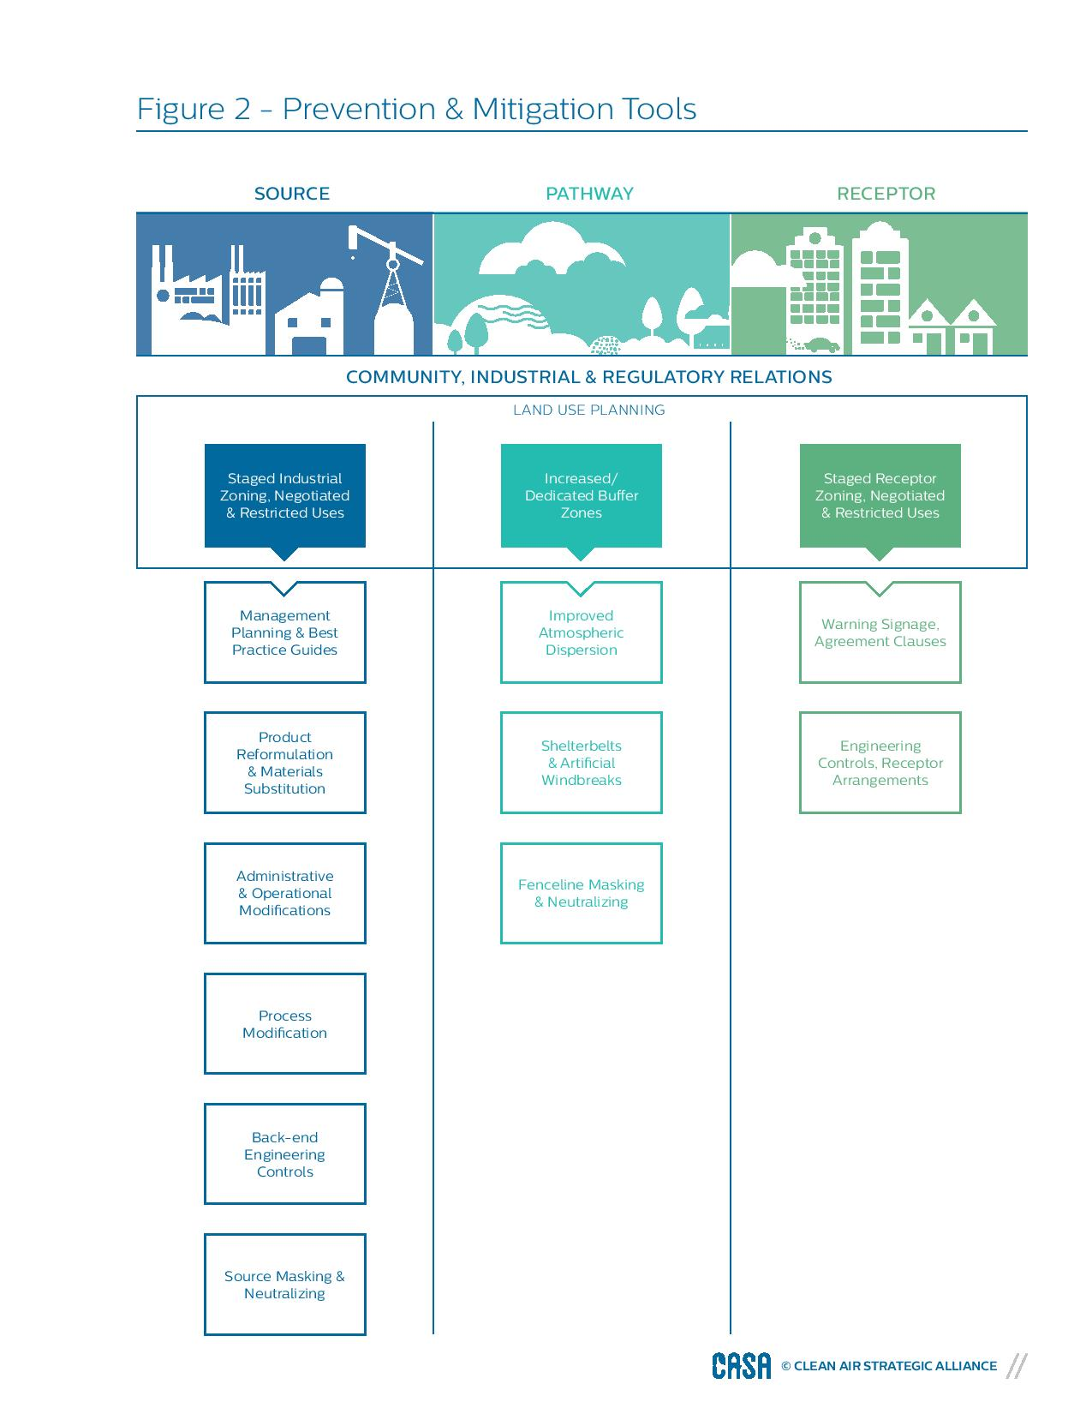

[**Table 2**](http://casahome.org/Portals/0/DMX/OMT%20GPG/CASA_GPG_webversion_Table02.pdf?timestamp=1444749707475) outlines Prevention and Mitigation Planning and Implementation steps. For many of these steps, the [**odour assessment tools**](http://casahome.org/CurrentInitiatives/GoodPracticesGuideforOdourManagementinAlberta/OdourAssessments.aspx) would be used.

[**Back to Top of Page**](http://casahome.org/CurrentInitiatives/GoodPracticesGuideforOdourManagementinAlberta/OdourPreventionandMitigation.aspx)